**Meet A Need (MAN)**

**Submitted by**

Sheraz Hassan (BCS02143329)

Hamza Amjad (BCS02143295)

Muhammad Shahbaz (BCS02143275)

**Submitted to**

Mr. Abid Bashir

**Degree**

Bachelor of Science in Computer Science



**Department**

Computer Science and IT



**“**Read! In the name of your Lord who created - Created the human from something which clings. Read! And your Lord is

Most Bountiful - He who taught (the use of) the Pen, Taught the human that which he knew not.”

(Al Quran)

**SIGNATURE PAGE**

**STATEMENT OF SUBMISSION:**

Submitted to **The University of Lahore** in partial fulfillment of the requirements for the award of degree of **Bachelors of Science in Computer Science (Honors).**

**SUBMITTED BY GROUP MEMBERS:**

**Sheraz Hassan (BCS02143329)**

**Hamza Amjad (BCS02143295)**

**Muhammad Shahbaz (BCS02143275)**

**SIR ABID BASHIR Project Advisor**

(Lecturer UOL)

Department of CS & IT

**Department of Computer Science & Information Technology**

**THE UNIVERSITY OF LAHORE**

**DEDICATION**

We are dedicating our project to our parents who supported us a lot in this project. They dedicated their full time on our project and made us capable to meet our Requirements regarding this unique project. Moreover, they supported us morally a Lot and motivated us to achieve this difficult target. May Almighty Allah always Shower His countless blessings on our parents. Without their knowledge, wisdom, and guidance, we would not have the goals we have to strive and be the best to reach our dreams.

**CHAPTER: 1**

**INTRODUCTION TO THE PROBLEM**

## **Introduction**

From the very start it has been a real problem that user cannot acquire data on a single site, they have to switch sites, search and compare their results. This act makes them anxious and a bit furious. By this project we are empowering customers by the amount of liberation and resources they can access through this website. Consumer’s effort is much reduced as there will be a no- visit in person and a very short time investment is needed. This is an open-source website so anyone can feel free to come and acquire what he need. Centralized database will provide updated and valid information to the users. User’s queries will be answered and they are allowed to give reviews and feedback. Similarly the administrator will keenly observe and keep the check and balance of this website. This system is designed to minimize the time investment and to facilitate the users by fulfilling their needs.

## **Purpose**

Web based advertising sites are appealing for several reasons which include People are getting more used to work with computers to do all sorts of things, namely sensitive operations such as shopping and home banking and they allow people to fetch information anywhere anytime, saves their precious time and get reviews about that particular thing. The main purpose of this system is to provide them comfort as well as 24 hours service without any difficulty.

## **Objectives**

The specific objectives of our project include:

1. **Reviewing:** Reviewing the existing/current websites in our Country.
2. **Facilitating:** Saving user’s time investment.
3. **Performance:** Providing information within no time irrespective of the number of users using the website.

## **Existing Solution**

Out of 1.9 billion (estimated) internet users all over the world, about 60 million (estimated) users belong to Pakistan. In this era of busy life, there is no such appropriate website where different Convenience Hotels, Restaurants can register themselves on a single platform and provide facility to user to get information. Moreover, busy users are forced to visit required need venue at the cost of their precious time. In this regard, they are required to spend time in finding their desired needed Hotels, Restaurants, Universities and Hospitals, then waiting in queues at counters to get informational details and back. There is utmost need of a system which can not only facilitate the owners of Hotels, Restaurants, Universities and Hospitals to attract customer but also make trip easier for customers. This fact increases the need of such web application where different Hotels &Restaurants and Hospitals place detailed information and customer can easily get that.

Also in other countries there are so many web applications like Yelp.com available where customers can get needed information at single platform only on a one tap away. But in Pakistan there is no such appropriate web application where different Hotels, Restaurants, Universities and Hospitals can register themselves and provide facility to user to get detailed required information.

## **Proposed Solution**

“Meet A Need” is a website where consumers are allowed to get Health, Universities, Hotel and Restaurant services that are provided at one single platform. Health sector would provide complete information about nearby hospitals, whereas Hotel and Restaurant sectors should highlight the hygienic, aseptic and best dines nearby as well as the optimum solution for staying or settling down for a day or two. University sector would provide complete information about nearby Universities. As a sitemap this will create awareness of what’s best and what’s where. Today’s consumers are empowered by the amount of liberation and resources they can access through web as everybody wants to meet his need at door. We are developing a web based application where user’s needs are met at a single platform by putting fewer efforts. There are Many websites that provide these services but not at a single platform. So we are proving a tab and put it up front and center that would cover all the aspect of Health, Hotel, Universities and Restaurants. The layout will be interactive and user friendly. Consumers would be satisfied by this as they are saving their precious time. Users don’t have to spend more of their time in getting their need fulfilled. Giving them variety of options to compare and choose what is best for them. Providing them comfort as well as 24 hours services. Our project is important because everybody will be able to achieve information in an easy way Safe, informational, professional and reasonable services for customers.

**CHAPTER: 2**

**Software Requirement Specification (SRS)**

**2.1 Introduction:**

This is the important chapter of our documentation as in it we will describe the functional and non-functional requirements of the system. In this chapter we will describe the user and system requirements**.** System requirements are more detailed requirements and may include more technical information.Requirements should be explained in such a manner that it would be easy for the user to understand it properly.

**2.1.1 Purpose:**

The purpose of this chapter is to make the functional and non-functional requirements of the Meet a Need System easy to comprehend. It also serves the users by providing particular information of hotels, hospitals and restaurants nearby him/her along with their timings, schedules, accommodation packages and everything a user is in need of. This purpose of our system will save the precious time of our users as don’t have to visit the site in person and his basic’s needs will be fulfilled just on one site. Our system alone will provide the answer, to the questions of different sections, like he/she will fetch information about hotels, hospitals and restaurants on this same site. Our system is designed in such a way that user can easily leave or read reviews. All the data will be saved in a DATABASE.

**2.1.2 Intended audience and reading suggestions**

The intended audience of this document is the potential end users. Registered users will get notified about new discoveries and will be updated accordingly while unregistered users will be deprived of such functionalities. Registered users will be prioritized in all cases.

**2.1.3 Scope:**

The software produced will be a web based Meet a Need system. The main objective of this site is to let our user considered aware of the verified and genuine information about hotels, hospitals, University and restaurants. The scope will be defined according to the user’s location as this site will facilitate the user by his/her nearby accommodations within Pakistan. It will maintain the database of all the eligible Hotels, Hospitals Universities and restaurants.

**2.1 Overall Description:**

**2.1.1 Product Perspective:**

This software product is a standalone system and not a part of a larger system. The system will be very fast and efficient. This system will be used for viewing profiles of different hotels, help to achieve an accommodation in any restaurant or looking for an emergency or a hospital. The users will reach the system through web pages by using web-browsers such as Mozilla, Internet Explorer and Google Chrome. Interface provided at these machines will help users to achieve what they want. User’s review information will be kept save in database and displayed on the site. Providing security to the user’s information is ours Product main goal.

**2.1.2 User Characteristic:**

Following are the characteristics of user

* The user should have a basic knowledge of how to use a web browser and navigate through web pages.
* The registered users should be aware that they have to keep their user-id and password conﬁdential.
* One should know English language.
* Every user should be comfortable with internet browser.
* User should be concerned about fair reviews.

**2.1.3 Constraints**

* User should know how to use internet
* A user cannot be registered twice.
* Login and password is used for identification of registered users.
* Admin should add only those users who have signed up for registration.

## **2.3 Specific Requirement:**

**2.3.1 User classes and characteristics:**

Users of meet a need system are those who wants result in less time in order to fulfill this requirement system should be fast, easy to understand and free of errors.

Project is divided in to main classes

**Customer:** They are the one who actually uses the system. They are divided into main three categories

* Owner
* Admin
* Users

**Developer**: The team of Meet a Need System are the developer. They can perform the cruds operations and can use the System. It’s their responsibility to check whether the system is working properly or not.

**Designer:** Those who have designed the website for Meet a Need system**.** They can only edit, change the design of the website. They know how to attract users by their design.

**Implementer:** Those who puts functional requirements in to practice. They only performs those functional requirements which are given by the developer. They cannot expand the functions of the system without the permission of the developer.

**MAN Users:** Those who only uses the system for achieving information. They are not allowed to edit or change anything**.**

**2.4 Operating Environment:**

The browsers through which the voters access the server should have minimal support for cookies and encrypted transactions. The product will be operating in windows environment. The MAN should operate in all famous browsers, for a model we are taking Microsoft Internet Explorer, Google Chrome, and Mozilla Firefox. Also it will be compatible with the IE 6.0. Most of the features will be compatible with the Mozilla Firefox & Opera 7.0 or higher version. The only requirement to use this system would be the internet connection.

**2.5 Non-Functional Requirement:**

1. **Performance Requirements:** The system is expected to have reasonable short time response. The user should be able to login and should be able to get response for his requests in 2-3 seconds.
2. **Network Connectivity:** Network Resources needs to be reliable. This system uses internet connectivity to be able to communicate with the web services and relies heavily on network connectivity. Network can be monitored and errors can be reported when there is a network connectivity issue.
3. **System Maintenance:** System will be used be using some additional components. Each of these components might need an update or changes. Applying these changes during the maintenance should be relatively easy.
4. **Usability:** It is expected that the user should be able to interact easily. Administration of the page also should be user friendly. Website should provide an online help to the user if needed just like tips for the beginners.
5. **Reliability:** The system should be reliable. Security is a concern for Meet A Need system. Process used in this system should be secure enough. It requires network connections and database connections. Changes cannot be done in the databases for the written reviews. The changes should be monitored.
6. **Supportability:** It should support all the browsers. Future enhancements or improvements can be considered during the design and development.
7. **Security:** The system should provide basic security features like password and authentication for the registered users. All the passwords generated and communicated to the users should be stored in the server only in an encrypted form for login management to prevent misuse.

**2.6 Technical specification:**

This section describes the high-level technical design for Meet A Need system. It details our technical goals.

**2.6.1 Hardware Requirements:**

As this application can be accessed via internet, only web server is required as a hardware interface to be able to run it. It is assumed that web server is in a secure environment with necessary firewall and network setting done**.**

**2.6.2 Software Requirement:**

The SRS document states precisely those functions and capabilities a software system must provide. It has four major goals:

* It provides feedback to customers.
* It divides the problem into different component parts.
* It gives an input to the design specification.
* It serves as a product validation check.

**2.7 Functional Requirements:**

Functional requirement is used to define a function of a system and its components. Functional

Requirements of MAN may be its technical details, data manipulation and processing and other specific functionality that define what a system is going to do**.**

* ID: FR_01
* Name: Admin Login

|  |  |  |  |
| --- | --- | --- | --- |
| Description | Input | Output | Basic work flow |
| Admin shall login to perform actions | Details of Admin  Admin ID  Admin Password | Admin login | enter username and password  Admin must press enter or login button |

* ID: FR_02
* Name: Admin Manage Website

|  |  |  |  |
| --- | --- | --- | --- |
| Description | Input | Output | Basic work flow |
| Admin shall Manage actions | Admin can perform different action on website | Admin Manage  Website | Clicks Add product and form is displayed  Fills required fields and  Click the Add product (Save button) |

* ID: FR_03
* Name: Email confirmation

|  |  |  |  |
| --- | --- | --- | --- |
| Description | Input | Output | Basic work flow |
| Admin shall confirm  Email of the accounts  of specific Customer  on creation, Deletion  And updating. | Customer ID  Customer name  Customer Email | Email send to the customer to  Confirm email account | Admin can send  Email and customer confirm the email on account edited, update and deleted in the record. |

* ID: FR_04
* Name: Admin Logout

|  |  |  |  |
| --- | --- | --- | --- |
| Description | Input | Output | Basic work flow |
| Admin shall logout | Details of Admin  Admin ID  Admin Password | Admin logout | Admin must press logout button |

* ID: FR_05
* Name: Add a New Hotel

|  |  |  |  |
| --- | --- | --- | --- |
| Description | Input | Output | Basic work flow |
| Admin shall Add  New Hotels details  And added in the record | Details of Hotel  Hotel Name  Hotel Address  Hotel  Contact Info  Description | Add new Hotel Details | Enter new Hotels details like name, Address, Phone No. Website Address, Google Map etc and added into the record. |

* ID: FR_06
* Name: View Hotel Details

|  |  |  |  |
| --- | --- | --- | --- |
| Description | Input | Output | Basic work flow |
| Admin shall View  All Hotels details | Details of Hotel  Hotel Name  Hotel ID | View Hotel Details | View All Hotels details like name, Address, Phone No. Website Address, Google Map etc. |

* ID: FR_07
* Name: Update Hotel Details

|  |  |  |  |
| --- | --- | --- | --- |
| Description | Input | Output | Basic work flow |
| Admin shall Update  Hotels details | Details of Hotel  Hotel Name  Hotel ID  Hotel Description | Hotel Details  Updated | Admin can Update Hotels details like name, Address, Phone No. Website Address, Google Map etc. |

* ID: FR_08
* Name: Delete Hotel Details

|  |  |  |  |
| --- | --- | --- | --- |
| Description | Input | Output | Basic work flow |
| Admin shall Delete  Hotels details | Details of Hotel  Hotel Name  Hotel ID  Hotel Description | Hotel Details  Is Deleted | Admin can Delete Hotels All details like name, Address, Phone No. Website Address, Google Map etc. |

* ID: FR_09
* Name: Admin Search

|  |  |  |  |
| --- | --- | --- | --- |
| Description | Input | Output | Basic work flow |
| Admin shall search  The Hotels details | Hotels name | All details of the Hotel Name  Contact info  Address etc | Admin can search the Hotels  From search button. |

* ID: FR_10
* Name: Add a Restaurant

|  |  |  |  |
| --- | --- | --- | --- |
| Description | Input | Output | Basic work flow |
| Admin shall Add  New Restaurant  details And added  in the record | Details of Restaurant  Restaurant Name  Restaurant Address Restaurant  Contact Info  Description | Add new Restaurant Details | Enter new Restaurant details like name, Address, Phone No. Website Address, Google Map etc and added into the record. |

* ID: FR_11
* Name: View Restaurant Details

|  |  |  |  |
| --- | --- | --- | --- |
| Description | Input | Output | Basic work flow |
| Admin shall View  All Restaurant details | Details of Restaurant  Restaurant Name  Restaurant ID | View Restaurant Details | View All Restaurant details like name, Address, Phone No. Website Address, Google Map etc. |

* ID: FR_12
* Name: Update Restaurant Details

|  |  |  |  |
| --- | --- | --- | --- |
| Description | Input | Output | Basic work flow |
| Admin shall Update  Restaurant details | Details of Restaurant  Restaurant Name  Restaurant ID  Restaurant Description | Restaurant Details  Updated | Admin can Update Restaurant details like name, Address, Phone No. Website Address, Google Map etc. |

* ID: FR_13
* Name: Delete Restaurant Details

|  |  |  |  |
| --- | --- | --- | --- |
| Description | Input | Output | Basic work flow |
| Admin shall Delete  Restaurant details | Details of Restaurant  Restaurant Name  Restaurant ID | Restaurant Details  Is Deleted | Admin can Delete Restaurant All details like name, Address, Phone No. Website Address, Google Map etc. |

* ID: FR_14
* Name: Admin Search

|  |  |  |  |
| --- | --- | --- | --- |
| Description | Input | Output | Basic work flow |
| Admin shall search  The Restaurant details | Restaurant name | All details of the Restaurant Name  Contact info  Address etc | Admin can search the Restaurant  From search button. |

* ID: FR_15
* Name: Add a Hospital

|  |  |  |  |
| --- | --- | --- | --- |
| Description | Input | Output | Basic work flow |
| Admin shall Add  New Hospital  details And added  in the record | Details of Hospital  Hospital Name  Hospital Address Hospital  Contact Info  Description | Add new Hospital Details | Enter new R Hospital details like name, Address, Phone No. Website Address, Google Map etc. and added into the record. |

* ID: FR_16
* Name: View Hospital Details

|  |  |  |  |
| --- | --- | --- | --- |
| Description | Input | Output | Basic work flow |
| Admin shall View  All Hospital details | Details of Hospital  Hospital Name  Hospital ID | View Hospital Details | View All Hospital details like name, Address, Phone No. Website Address, Google Map etc. |

* ID: FR_17
* Name: Update Hospital Details

|  |  |  |  |
| --- | --- | --- | --- |
| Description | Input | Output | Basic work flow |
| Admin shall Update  Hospital details | Details of Hospital  Hospital Name  Hospital ID  Hospital Description | Hospital Details  Updated | Admin can Update Hospital details like name, Address, Phone No. Website Address, Google Map etc. |

* ID: FR_18
* Name: Delete Hospital Details

|  |  |  |  |
| --- | --- | --- | --- |
| Description | Input | Output | Basic work flow |
| Admin shall Delete  Hospital details | Details of Hospital  Hospital Name  Hospital ID | Hospital Details  Is Deleted | Admin can Delete Hospital All details like name, Address, Phone No. Website Address, Google Map etc. |

* ID: FR_19
* Name: Admin Search

|  |  |  |  |
| --- | --- | --- | --- |
| Description | Input | Output | Basic work flow |
| Admin shall search  The Hospital details | Hospital name | All details of the Hospital Name  Contact info  Address etc. | Admin can search the Hospital  From search button. |

* ID: FR_20
* Name: Add a University

|  |  |  |  |
| --- | --- | --- | --- |
| Description | Input | Output | Basic work flow |
| Admin shall Add  New University  details And added  in the record | Details of University  University Name  University Address University  Contact Info  Description | Add new University Details | Enter new University details like name, Address, Phone No. Website Address, Google Map etc. and added into the record. |

* ID: FR_21
* Name: View University Details

|  |  |  |  |
| --- | --- | --- | --- |
| Description | Input | Output | Basic work flow |
| Admin shall View  All University details | Details of University  University Name  University ID | View University Details | View All University details like name, Address, Phone No. Website Address, Google Map etc. |

* ID: FR_22
* Name: Update University Details

|  |  |  |  |
| --- | --- | --- | --- |
| Description | Input | Output | Basic work flow |
| Admin shall Update  University details | Details of University  University Name  University ID  University Description | University Details  Updated | Admin can Update University details like name, Address, Phone No. Website Address, Google Map etc. |

* ID: FR_23
* Name: Delete University Details

|  |  |  |  |
| --- | --- | --- | --- |
| Description | Input | Output | Basic work flow |
| Admin shall Delete  University details | Details of University  University Name  University ID | University Details  Is Deleted | Admin can Delete University All details like name, Address, Phone No. Website Address, Google Map etc. |

* ID: FR_24
* Name: Admin Search

|  |  |  |  |
| --- | --- | --- | --- |
| Description | Input | Output | Basic work flow |
| Admin shall search  The University details | University name | All details of the University Name  Contact info  Address etc. | Admin can search the University  From search button. |

* ID: FR_25
* Name: User Signup

|  |  |  |  |
| --- | --- | --- | --- |
| Description | Input | Output | Basic work flow |
| User shall Signup. | Details of User  User Name  Password  Password Confirm  Email | User Signup | Enter the username, password and Email and press on Signup button |

* ID: FR_26
* Name: User Login

|  |  |  |  |
| --- | --- | --- | --- |
| Description | Input | Output | Basic work flow |
| User shall login to perform actions | Details of User  User Name and  Password | User login | enter username and password  User must press enter or login button |

* ID: FR_27
* Name: User Logout

|  |  |  |  |
| --- | --- | --- | --- |
| Description | Input | Output | Basic work flow |
| User shall logout | Details of User  User Name  And Password | User logout | User must press logout button |

* ID: FR_28
* Name: Password recovery

|  |  |  |  |
| --- | --- | --- | --- |
| Description | Input | Output | Basic work flow |
| User shall Recover  Account Password | Details of User  User Name  And Email Address | Password Recovery | User must Provide the Email Address And Confirm through that mail to recover Password. |

* ID: FR_29
* Name: User Search Hospital

|  |  |  |  |
| --- | --- | --- | --- |
| Description | Input | Output | Basic work flow |
| User shall search  The Hospital details | Hospital name | All details of the Hospital Name  Contact info  Address etc. | User can search the Hospital From search button. |

* ID: FR_30
* Name: User View Hospital Details

|  |  |  |  |
| --- | --- | --- | --- |
| Description | Input | Output | Basic work flow |
| User shall View  All Hospital details | Details of Hospital  Hospital Name  Hospital ID | View Hospital Details | View All Hospital details like name, Address, Phone No. Website Address, Google Map etc. |

* ID: FR_31
* Name: User Search Hotels

|  |  |  |  |
| --- | --- | --- | --- |
| Description | Input | Output | Basic work flow |
| User shall search  The Hotels details | Hotels name | All details of the Hotels Name  Contact info  Address etc. | User can search the Hotels From search button. |

* ID: FR_32
* Name: User View Hotels Details

|  |  |  |  |
| --- | --- | --- | --- |
| Description | Input | Output | Basic work flow |
| User shall View  All Hotels details | Details of Hotels  Hotels Name  Hotels ID | View Hotels Details | View All Hotels details like name, Address, Phone No. Website Address, Google Map etc. |

* ID: FR_33
* Name: User Search Restaurants

|  |  |  |  |
| --- | --- | --- | --- |
| Description | Input | Output | Basic work flow |
| User shall search  The Restaurants details | Restaurants name | All details of the Restaurants Name  Contact info  Address etc. | User can search the Restaurants From search button. |

* ID: FR_34
* Name: User View Restaurants Details

|  |  |  |  |
| --- | --- | --- | --- |
| Description | Input | Output | Basic work flow |
| User shall View  All Restaurants details | Details of Restaurants  Restaurants Name  Restaurants ID | View Restaurants Details | View All Restaurants details like name, Address, Phone No. Website Address, Google Map etc. |

* ID: FR_35
* Name: User Search University

|  |  |  |  |
| --- | --- | --- | --- |
| Description | Input | Output | Basic work flow |
| User shall search  The University details | University name | All details of the University Name  Contact info  Address etc. | User can search the University From search button. |

* ID: FR_36
* Name: User View University Details

|  |  |  |  |
| --- | --- | --- | --- |
| Description | Input | Output | Basic work flow |
| User shall View  All University details | Details of University  University Name  University ID | View University Details | View All University details like name, Address, Phone No. Website Address, Google Map etc. |

# **CHAPTER: 3**

**ANALYSIS (USE CASE DESCRIPTION AND USE CASE MODEL)**

## **Use Case Model**

A use case diagram is a graphic depiction of the interaction among the elements of a system. A use case is a methodology used in system analysis to identify, clarify and organize system requirements. A use case represents a discrete unit of interaction between a user and the system. The use case diagrams provided below is direct correspondence with each of the functional requirements item discussed in the requirement section of the report.

### **Vision**

Meet A Need (MAN) target the audience those are interested in provide services by MAN without going to any physically. The main purpose of this system is to provide them comfort as well as 24 hours service without any difficulty.

### **Super-Admin Use Case**

**Operation: Admin Login**

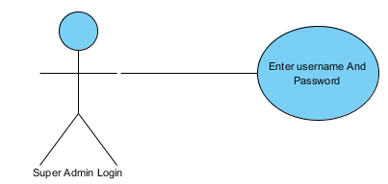

Figure 1

|  |  |
| --- | --- |
| ID | UC_01 |
| Name | Admin Login |
| Actor | Super-admin |
| Description | Admin can Login |
| Pre-condition | * Username * Password |
| Post-condition | Admin is login Successfully |
| Basic Flow | * Admin system home page. * Admin clicks “login” button. * Enters username and password. * Now the admin is login. |
| Alternative Flow | If the username and password is wrong error message will be shown. |

Table 3‑1

**Operation: Admin Manage Website**

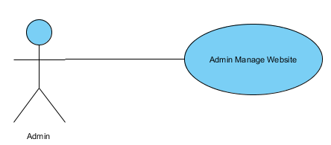

Figure 2

|  |  |
| --- | --- |
| ID | UC_02 |
| Name | Admin Manage Website |
| Actor | Admin |
| Description | Admin shall Manage actions |
| Pre-condition | Admin can perform different action on website |
| Post-condition | Admin can manage Website Management |
| Basic Flow | * Clicks Add product * Fills required fields * Click the Add product (Save button) |
| Alternative Flow | None |

Table 3‑2

**Operation: Email confirmation of an Account**

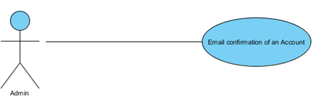

Figure 3

|  |  |
| --- | --- |
| ID | UC_03 |
| Name | Email confirmation of an Account |
| Actor | Admin |
| Description | Admin shall confirm Email of the accounts of specific Customer on creation, Deletion And updating. |
| Pre-condition | Customer ID Customer name Customer Email |
| Post-condition | Email send to the customer to Confirm email account |
| Basic Flow | * Admin can send Email * Customer confirm the email on account edited, update |
| Alternative Flow | None |

Table 3‑3

**Operation: Admin Logout**

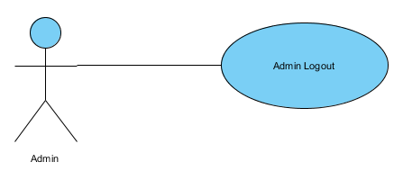

Figure 4

|  |  |
| --- | --- |
| ID | UC_04 |
| Name | Admin Logout |
| Actor | Admin |
| Description | Admin shall logout |
| Pre-condition | Clicks logout button. |
| Post-condition | Admin is logout Successfully |
| Basic Flow | * Admin clicks “logout” button. * Now Admin is logout. |
| Alternative Flow | None |

Table 3‑4

**Operation: Add a New Hotel**

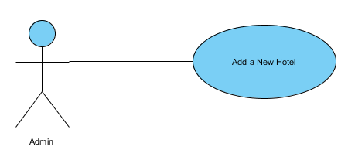

Figure 5

|  |  |
| --- | --- |
| ID | UC_05 |
| Name | Add A New Hotel |
| Actor | Admin |
| Description | Admin shall Add New Hotels details And added in the record |
| Pre-condition | * Hotel Name * Hotel Address * Hotel Contact Info * Description |
| Post-condition | Add new Hotel Details |
| Basic Flow | * Enter new Hotels details like * Name * Address * Phone No. * Website Address * Google Map * Added into the record |
| Alternative Flow | None |

Table 3‑5

**Operation: View Hotel Details**

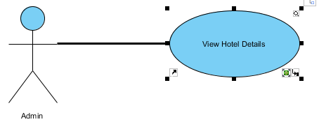

Figure 6

|  |  |
| --- | --- |
| ID | UC_06 |
| Name | View Hotel Details |
| Actor | Admin |
| Description | Admin shall View All Hotels details |
| Pre-condition | * Hotel Name * Hotel ID |
| Post-condition | View Hotel Detail |
| Basic Flow | * Clicks the view button. * View All Hotels details like * Name * Address * Phone No * Website Address * Google Map |
| Alternative Flow | If the Hotel Name and Hotel ID wrong error message will be shown. |

Table 3‑6

**Operation: Update Hotel Details**

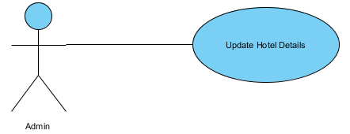

Figure 7

|  |  |
| --- | --- |
| ID | UC_07 |
| Name | Update Hotel Details |
| Actor | Admin |
| Description | Admin shall Update Hotels details |
| Pre-condition | * Hotel Name * Hotel ID |
| Post-condition | Hotel Details Updated Successfully |
| Basic Flow | * Clicks the update button. * Admin can Update Hotels details like * Name * Address * Phone No * Website Address * Google Map |
| Alternative Flow | None |

Table 3‑7

**Operation: Delete Hotel Details**

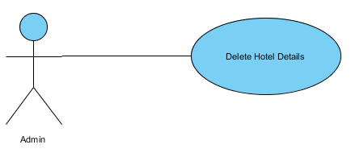

FIGURE 8

|  |  |
| --- | --- |
| ID | UC_08 |
| Name | Delete Hotel Details |
| Actor | Admin |
| Description | Admin shall Delete Hotels details |
| Pre-condition | * Hotel Name * Hotel ID |
| Post-condition | Hotel Details Is Deleted Successfully |
| Basic Flow | * Clicks the delete button. * Admin can Delete Hotels All details like * Name * Address * Phone No. * Website Address * Google Map |
| Alternative Flow | None |

Table 3-8

**Operation: Admin Search Hotels**

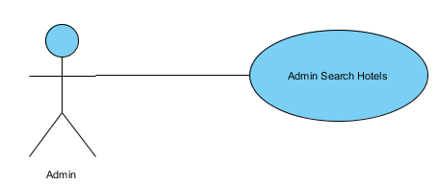

FIGURE 9

|  |  |
| --- | --- |
| ID | UC_09 |
| Name | Admin Search Hotels |
| Actor | Admin |
| Description | Admin shall search The Hotels details |
| Pre-condition | Clicks the search button. |
| Post-condition | * Hotel Name * Contact info * Address |
| Basic Flow | * Clicks “Search” button. * Enter Hotel name. * Complete details are shown. |
| Alternative Flow | None |

Table 3-9

**Operation: Add a New Restaurant**

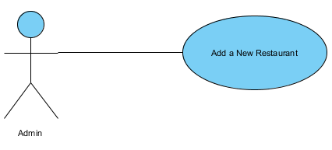

FIGURE 10

|  |  |
| --- | --- |
| ID | UC_10 |
| Name | Add a New Restaurant |
| Actor | Admin |
| Description | Admin shall Add New Restaurant details And added in the record |
| Pre-condition | * Details of Restaurant * Restaurant Name * Restaurant Address * Restaurant * Contact Info * Description |
| Post-condition | Added new Restaurant Details Successfully |
| Basic Flow | * Enter new Restaurant details like * Name * Address * Phone No * Website Address * Google Map * added into the record |
| Alternative Flow | None |

Table 3-10

**Operation: View Restaurant Details**

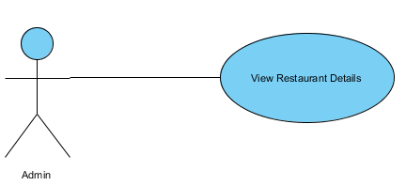

FIGURE 11

|  |  |
| --- | --- |
| ID | UC_11 |
| Name | View Restaurant Details |
| Actor | Admin |
| Description | Admin shall View All Restaurant details |
| Pre-condition | * Restaurant Name * Restaurant ID |
| Post-condition | Restaurant Details Viewed successfully |
| Basic Flow | * Clicks the view button. * View All Restaurant details like * Name * Address * Phone No. * Website Address * Google Map |
| Alternative Flow | None |

Table 3-11

**Operation: Update Restaurant Details**

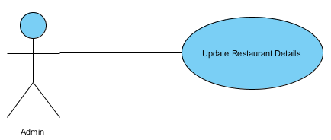

FIGURE 12

|  |  |
| --- | --- |
| ID | UC_12 |
| Name | Update Restaurant Details |
| Actor | Admin |
| Description | Admin shall Update Restaurant details |
| Pre-condition | * Restaurant Name * Restaurant ID |
| Post-condition | Restaurant Details Updated Successfully |
| Basic Flow | * Clicks the update button. * Admin can Update Restaurant details like * Name * Address * Phone No. * Website Address * Google Map |
| Alternative Flow | None |

Table 3-12

**Operation: Delete Restaurant Details**

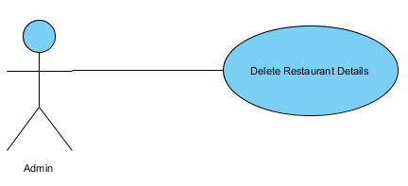

FIGURE 13

|  |  |
| --- | --- |
| ID | UC_13 |
| Name | Delete Restaurant Details |
| Actor | Admin |
| Description | Admin shall Delete Restaurant details |
| Pre-condition | * Restaurant Name * Restaurant ID |
| Post-condition | Restaurant Details Is Deleted Successfully |
| Basic Flow | * Clicks the delete button. * Admin can Delete Restaurant All details like * Name * Address * Phone No * Website |
| Alternative Flow | None |

Table 3-13

**Operation: Admin Search Restaurants**

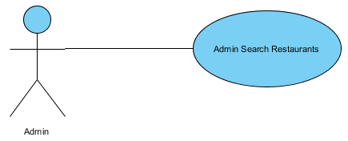

FIGURE 14

|  |  |
| --- | --- |
| ID | UC_14 |
| Name | Admin Search Restaurants |
| Actor | Admin |
| Description | Admin shall search The Restaurant details |
| Pre-condition | Clicks the search button. |
| Post-condition | All details of the Restaurant Name Contact info Address etc |
| Basic Flow | * Clicks “Search” button. * Enter Restaurant name. * Complete details are shown. |
| Alternative Flow | None |

Table 3-14

**Operation: Add a Hospital**

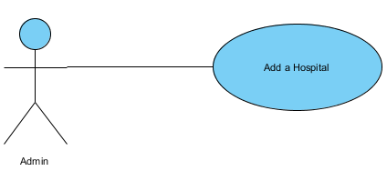

FIGURE 15

|  |  |
| --- | --- |
| ID | UC_15 |
| Name | Add a Hospital |
| Actor | Admin |
| Description | Admin shall Add New Hospital details And added in the record |
| Pre-condition | * Details of Hospital * Hospital Name * Hospital Address * Hospital Contact Info * Description |
| Post-condition | New Hospital Details added successfully |
| Basic Flow | * Enter new Hospital details like * Name * Address * Phone No. * Website Address * Google Map etc. * Added into the record |
| Alternative Flow | None |

Table 3-15

**Operation: View Restaurant Details**

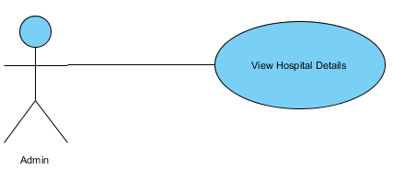

FIGURE 16

|  |  |
| --- | --- |
| ID | UC_16 |
| Name | View Hospital Details |
| Actor | Admin |
| Description | Admin shall View All Hospital details |
| Pre-condition | * Hospital Name * Hospital ID |
| Post-condition | Hospital Details Viewed successfully |
| Basic Flow | * Clicks the view button. * View All Hospital details like * Name * Address * Phone No. * Website Address * Google Map |
| Alternative Flow | None |

Table 3-16

**Operation: Update Hospital Details**

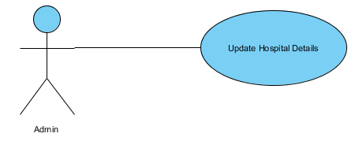

FIGURE 17

|  |  |
| --- | --- |
| ID | UC_17 |
| Name | Update Hospital Details |
| Actor | Admin |
| Description | Admin shall Update Hospital details |
| Pre-condition | * Details of Hospital * Hospital Name * Hospital ID |
| Post-condition | Hospital Details Updated Successfully |
| Basic Flow | * Clicks the update button. * Admin can Update Hospital details like * Name * Address * Phone No. * Website Address * Google Map |
| Alternative Flow | None |

Table 3-17

**Operation: Delete Hospital Details**

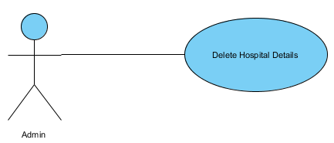

FIGURE 18

|  |  |
| --- | --- |
| ID | UC_18 |
| Name | Delete Hospital Details |
| Actor | Admin |
| Description | Admin shall Delete Hospital details |
| Pre-condition | * Hospital Name * Hospital ID |
| Post-condition | Hospital Details Is Deleted Successfully |
| Basic Flow | * Clicks the delete button. * Admin can Delete Hospital All details like * Name * Address * Phone No * Website |
| Alternative Flow | None |

Table 3-18

**Operation: Admin Search Hospitals**

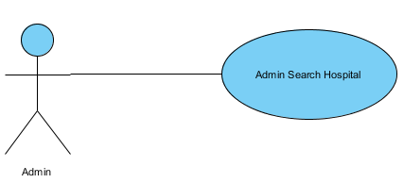

FIGURE 19

|  |  |
| --- | --- |
| ID | UC_19 |
| Name | Admin Search Hospitals |
| Actor | Admin |
| Description | Admin shall search The Hospital details |
| Pre-condition | Clicks the search button. |
| Post-condition | All details of the Hospital Name Contact info Address etc |
| Basic Flow | * Clicks “Search” button. * Enter Hospital name. * Complete details are shown. |
| Alternative Flow | None |

Table 3-19

**Operation: Add a University**

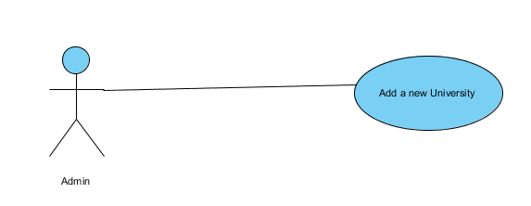

FIGURE 20

|  |  |
| --- | --- |
| ID | UC_20 |
| Name | Add a University |
| Actor | Admin |
| Description | Admin shall Add New University details And added in the record |
| Pre-condition | Details of University   * University Name * University Address University * Contact Info * Description |
| Post-condition | Added new University Details |
| Basic Flow | Enter new University details like   * University Name * Address * Phone No. * Website Address * Google Map etc. |
| Alternative Flow | None |

Table 3-20

**Operation: View University Details**

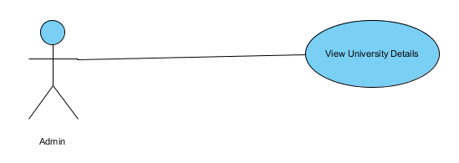

FIGURE 21

|  |  |
| --- | --- |
| ID | UC_21 |
| Name | View University Details |
| Actor | Admin |
| Description | Admin shall View All University details |
| Pre-condition | Details of University   * University Name * University ID |
| Post-condition | View University Details |
| Basic Flow | Clicks the view button View All University details like   * Name * Address * Phone No. * Website Address * Google Map etc. |
| Alternative Flow | None |

Table 3-21

**Operation: Update University Details**

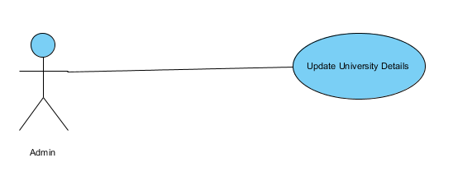

FIGURE 22

|  |  |
| --- | --- |
| ID | UC_22 |
| Name | Update University Details |
| Actor | Admin |
| Description | Admin shall Update University details |
| Pre-condition | Details of University   * University Name * University ID * University Description |
| Post-condition | University Details Updated |
| Basic Flow | * Clicks the update button Admin can Update University details like * Name * Address * Phone No. * Website Address * Google Map etc. |
| Alternative Flow | None |

Table 3-22

**Operation: Delete University Details**

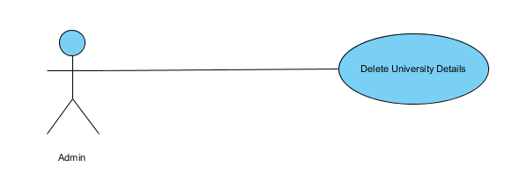FIGURE 23

|  |  |
| --- | --- |
| ID | UC_23 |
| Name | Delete University Details |
| Actor | Admin |
| Description | Admin shall Delete University details |
| Pre-condition | Details of University   * University Name * University ID |
| Post-condition | University Details Is Deleted |
| Basic Flow | Clicks the delete button Admin can Delete University All details like   * Name * Address * Phone No. * Website Address * Google Map etc. |
| Alternative Flow | None |

Table 3-23

**Operation: Admin Search University**

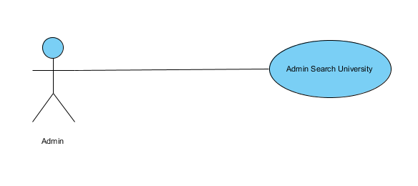FIGURE 24

|  |  |
| --- | --- |
| ID | UC_24 |
| Name | Admin Search University |
| Actor | Admin |
| Description | Admin shall search The University details |
| Pre-condition | Clicks the search button. |
| Post-condition | All details of the University   * Name * Contact info * Address etc. |
| Basic Flow | * Clicks “Search” button. * Enter University name. * Complete details are shown. |
| Alternative Flow | None |

Table 3-24

**Operation: User Signup**

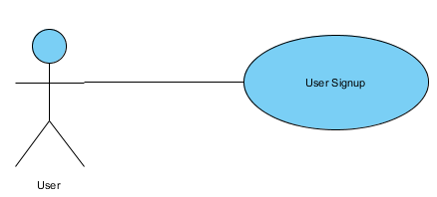

FIGURE 25

|  |  |
| --- | --- |
| ID | UC_25 |
| Name | User Signup |
| Actor | User |
| Description | User shall Signup into the system |
| Pre-condition | * Basic Details of User * Name * Gender * Email Address * Contact Info * City or Town * Description * Choose username * Create a password * Confirm your password |
| Post-condition | New User Signup successfully |
| Basic Flow | * User clicks “Sign Up” button. * Fills sign up form * Now the User is registered. |
| Alternative Flow | One registration per Email. |

Table 3-25

**Operation: User Login**

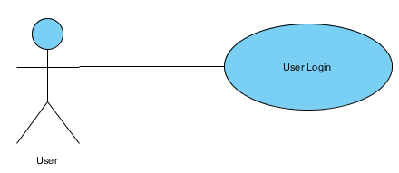

Figure 26

|  |  |
| --- | --- |
| ID | UC_26 |
| Name | User Login |
| Actor | User |
| Description | User shall login to perform actions |
| Pre-condition | * Username * Password |
| Post-condition | User is login Successfully |
| Basic Flow | * User system home page. * User clicks “login” button. * Enters username and password. * Now the User is login. |
| Alternative Flow | If the username and password is wrong error message will be shown. |

Table 3‑26

**Operation: User Logout**

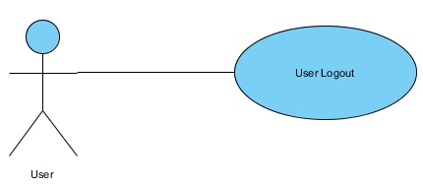

Figure 27

|  |  |
| --- | --- |
| ID | UC_27 |
| Name | User Logout |
| Actor | User |
| Description | User shall logout |
| Pre-condition | * Username * Password |
| Post-condition | User is logout Successfully |
| Basic Flow | * User click the “logout” button. * Now User is logout. |
| Alternative Flow | None |

Table 3‑27

**Operation: User Recover Password**

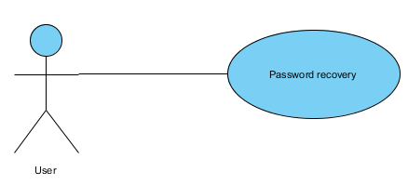

FIGURE 28

|  |  |
| --- | --- |
| ID | UC_28 |
| Name | User recover Account password |
| Actor | User |
| Description | User shall Recover Account Password |
| Pre-condition | * Answer security question * New password * Confirm password |
| Post-condition | User Recover Account Password successfully |
| Basic Flow | * User wants to change password. * Answer security question. * Enter current password. * Enter new password. * Now password is changed |
| Alternative Flow | None |

Table 3-28

**Operation: User Search Hospitals**

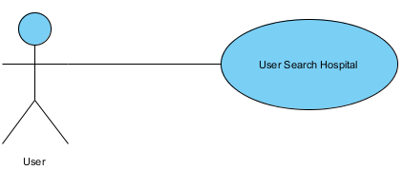

FIGURE 29

|  |  |
| --- | --- |
| ID | UC_29 |
| Name | User Search Hospitals |
| Actor | User |
| Description | User shall search The Hospital details |
| Pre-condition | Clicks the search button. |
| Post-condition | All details of the Hospital Name Contact info Address etc |
| Basic Flow | * Clicks “Search” button. * Enter Hospital name. * Complete details are shown. |
| Alternative Flow | None |

Table 3-29

**Operation: View Hospital Details**

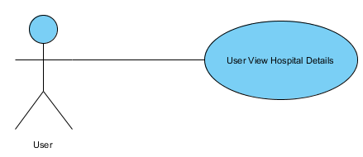

FIGURE 30

|  |  |
| --- | --- |
| ID | UC_30 |
| Name | View Hospital Details |
| Actor | User |
| Description | User shall View All Hospital details |
| Pre-condition | * Hospital Name * Hospital ID |
| Post-condition | Hospital Details Viewed successfully |
| Basic Flow | * View All Hospital details like * Name * Address * Phone No. * Website Address * Google Map |
| Alternative Flow | None |

Table 3-30

**Operation: User Search Hotels**

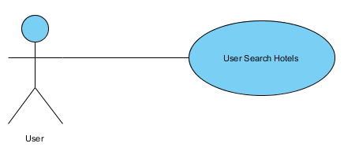

FIGURE 31

|  |  |
| --- | --- |
| ID | UC_31 |
| Name | User Search Hotels |
| Actor | User |
| Description | User shall search The Hotels details |
| Pre-condition | Clicks the search button. |
| Post-condition | All details of the Hotels Name Contact info Address etc |
| Basic Flow | * Clicks “Search” button. * Enter Hotels name. * Complete details are shown. |
| Alternative Flow | None |

Table 3-31

**Operation: View Hotels Details**

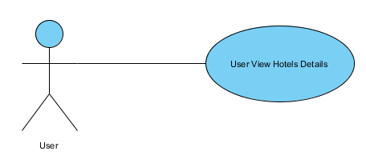

FIGURE 32

|  |  |
| --- | --- |
| ID | UC_32 |
| Name | View Hotels Details |
| Actor | User |
| Description | User shall View All Hotels details |
| Pre-condition | * Hotels Name * Hotels ID |
| Post-condition | Hotels Details Viewed successfully |
| Basic Flow | * View All Hotels details like * Name * Address * Phone No. * Website Address * Google Map |
| Alternative Flow | None |

Table 3-32

**Operation: User Search Restaurants**

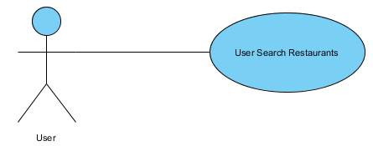

FIGURE 33

|  |  |
| --- | --- |
| ID | UC_33 |
| Name | User Search Restaurants |
| Actor | User |
| Description | User shall search The Restaurants details |
| Pre-condition | Clicks the search button. |
| Post-condition | All details of the Restaurants Name Contact info Address etc |
| Basic Flow | * Clicks “Search” button. * Enter Restaurant name. * Complete details are shown. |
| Alternative Flow | None |

Table 3-33

**Operation: View Restaurants Details**

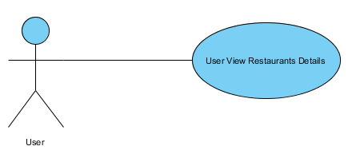

FIGURE 34

|  |  |
| --- | --- |
| ID | UC_34 |
| Name | View Restaurants Details |
| Actor | User |
| Description | User shall View All Restaurants details |
| Pre-condition | * Restaurants Name * Restaurants ID |
| Post-condition | Restaurants Details Viewed successfully |
| Basic Flow | * View All Restaurants details like * Name * Address * Phone No. * Website Address * Google Map |
| Alternative Flow | None |

Table 3-34

**Operation: User Search University**

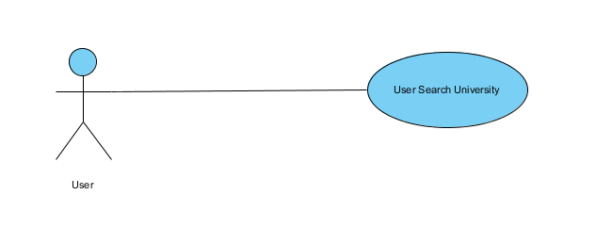

FIGURE 35

|  |  |
| --- | --- |
| ID | UC_35 |
| Name | User Search University |
| Actor | User |
| Description | User shall search The University details |
| Pre-condition | Clicks the search button. |
| Post-condition | All details of the University   * Name * Contact info * Address * Description |
| Basic Flow | * Clicks “Search” button. * Enter University name. * Complete details are shown. |
| Alternative Flow | None |

Table 3-35

**Operation: View University Details**

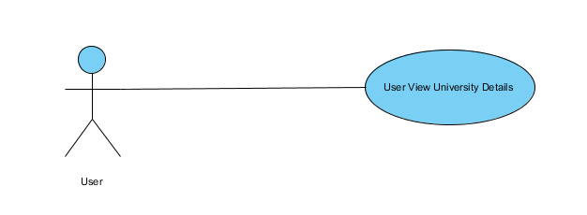

FIGURE 36

|  |  |
| --- | --- |
| ID | UC_36 |
| Name | View University Details |
| Actor | User |
| Description | User shall View All University details |
| Pre-condition | Details of University   * University Name * University ID |
| Post-condition | Viewed University Details |
| Basic Flow | View All University details like   * Name * Address * Phone No. * Website Address * Google Map |
| Alternative Flow | None |

Table 3-36

# **CHAPTER: 4**

Design

# **Architecture Diagram**

Any real world system is used by different users. The users can be developers, testers, business people, analysts and many more. So before designing a system the architecture is made with different perspectives in mind. The most important part is to visualize the system from different viewer’s perspective. The better we understand the better we make the system.

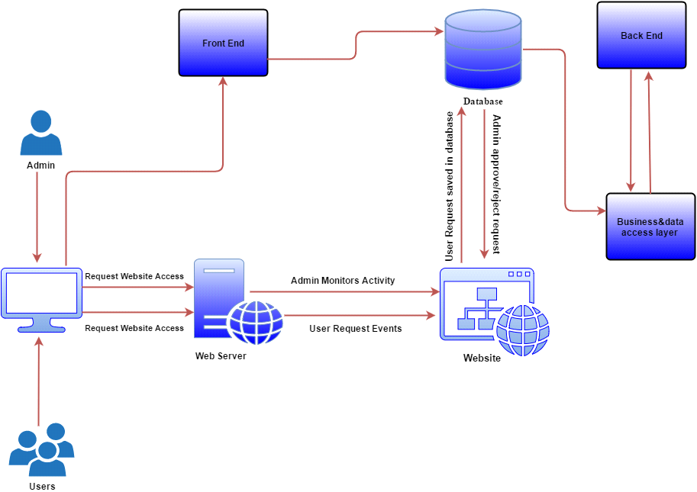

Figure 4-1

**Entity Relation Diagram**

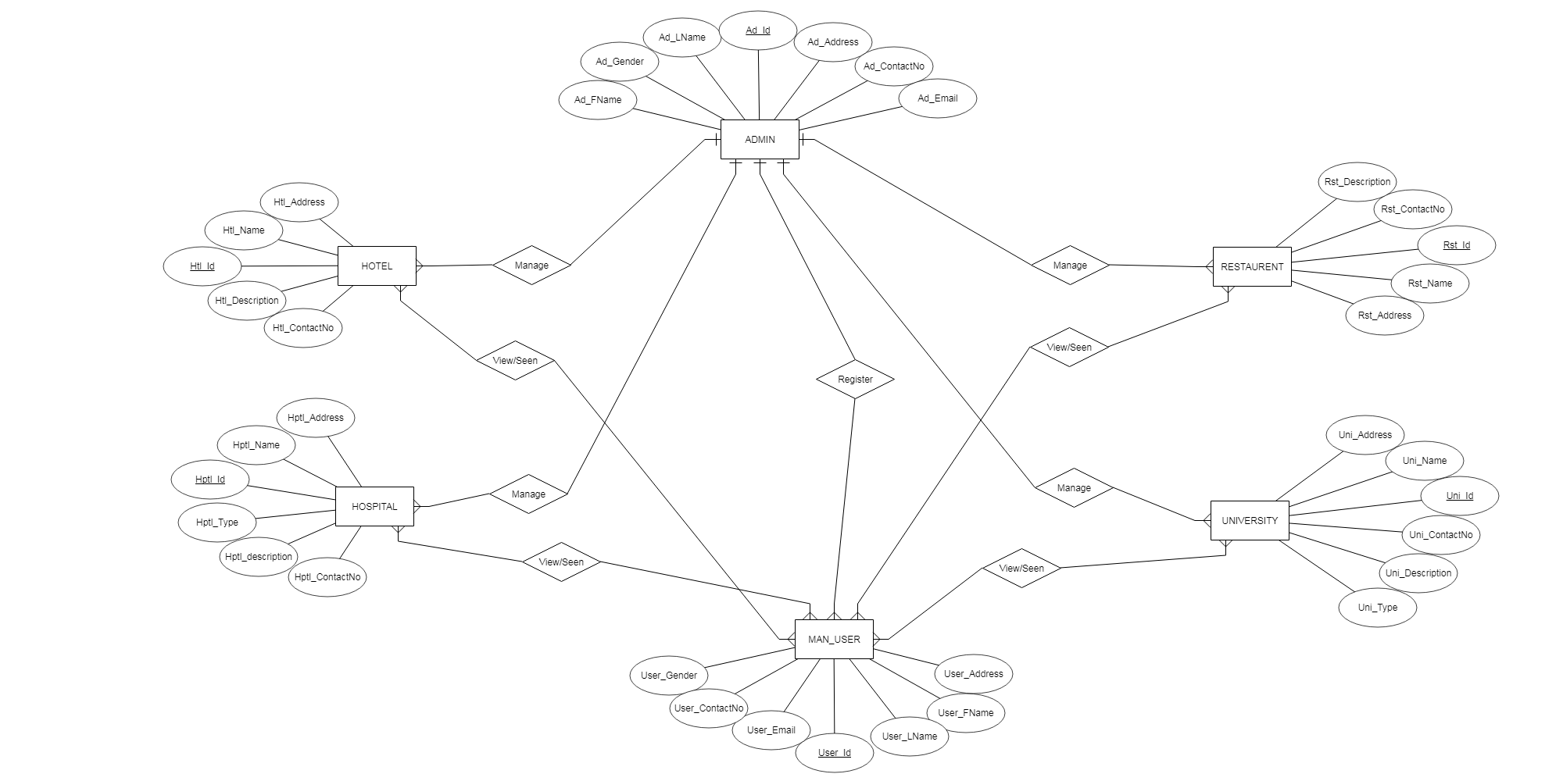

Figure 4-2

**Data Dictionary**

**Admin**

|  |  |  |
| --- | --- | --- |
| **Name** | **Type** | **Null** |
| Ad_Id | Varchar(10) | No |
| Ad_Fname | Varchar(15) | No |
| Ad_Lname | Varchar(15) | No |
| Ad_Address | Varchar(30) | No |
| Ad_Gender | Varchar(05) | No |
| Ad_Email | Varchar(25) | No |
| Ad_ContactNo | Int(12) | No |

Table 4.2.1

**Hotel**

|  |  |  |
| --- | --- | --- |
| **Name** | **Type** | **Null** |
| Htl_Id | Varchar(10) | No |
| Htl_Name | Varchar(30) | No |
| Htl_Address | Varchar(50) | No |
| Htl_ContactNo | Int(12) | No |
| Htl_Description | Varchar(150) | No |

Table 4.2.2

**Restaurent**

|  |  |  |
| --- | --- | --- |
| **Name** | **Type** | **Null** |
| Rst_Id | Varchar(10) | No |
| Rst _Name | Varchar(30) | No |
| Rst _Address | Varchar(50) | No |
| Rst _ContactNo | Int(12) | No |
| Rst _Description | Varchar(150) | No |

Table 4.2.3

**Hospital**

|  |  |  |
| --- | --- | --- |
| **Name** | **Type** | **Null** |
| Hptl_Id | Varchar(10) | No |
| Hptl_Name | Varchar(30) | No |
| Hptl_Address | Varchar(50) | No |
| Hptl_ContactNo | Int(12) | No |
| Hptl_Type | Varchar(15) | No |
| Hptl_Description | Varchar(150) | No |

Table 4.2.4

**University**

|  |  |  |
| --- | --- | --- |
| **Name** | **Type** | **Null** |
| Uni_Id | Varchar(10) | No |
| Uni _Name | Varchar(25) | No |
| Uni _Address | Varchar(50) | No |
| Uni _ContactNo | Int(12) | No |
| Uni _Type | Varchar(15) | No |
| Uni _Description | Varchar(150) | No |

Table 4.2.5

**MAN_User**

|  |  |  |
| --- | --- | --- |
| **Name** | **Type** | **Null** |
| User_Id | Varchar(10) | No |
| User _Fname | Varchar(15) | No |
| User _Lname | Varchar(15) | No |
| User _Address | Varchar(30) | No |
| User _Gender | Varchar(05) | No |
| User _Email | Varchar(25) | No |
| User _ContactNo | Int(12) | No |

Table 4.2.6

**Data Flow Diagram (Level 0)**

A context diagram is a top level (also known as "Level 0") data flow diagram. It only contains one process node Process 0 that generalizes the function of the entire system in relationship to external entities.

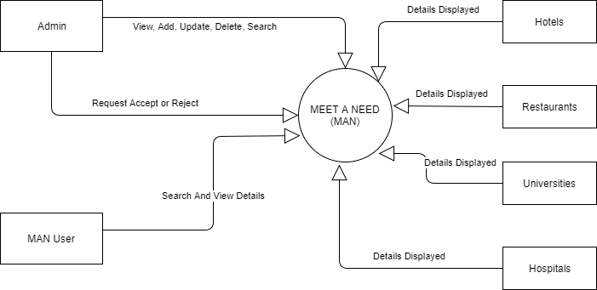

Figure 4-3

**Data flow diagram (level 1)**

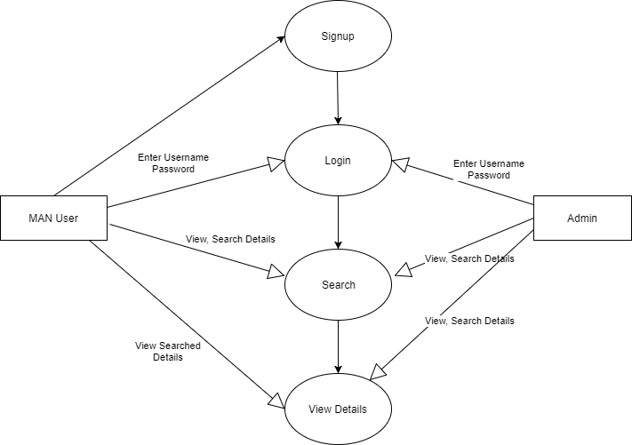

Figure 4-4

**Class Diagram**

The purpose of the class diagram is to model the static view of an application. The class diagrams are the only diagrams which can be directly mapped with object oriented languages and thus widely used at the time of construction.

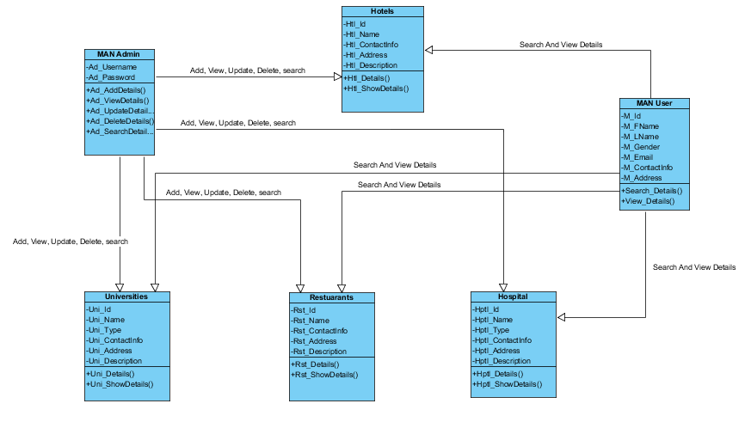

Figure 4-5

**Collaboration Diagram**

**Admin**

* Login
* Manage website
* Conform email account
* Logout
* Add a Hotel
* View Hotel details
* Update Hotel details
* Delete Hotel details
* Search Hotel details
* Add a Restaurant
* View Restaurant details
* Update Restaurant details
* Delete Restaurant details
* Search Restaurant details
* Add a Hospital
* View Hospital details
* Update Hospital details
* Delete Hospital details
* Search Hospital details
* Add a University
* View University details
* Update University details
* Delete University details
* Search University details

**Login**

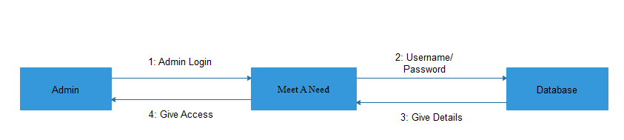

Figure 4.6.1

**Manage website**

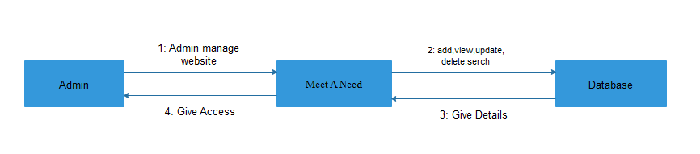

Figure 4.6.2

**Conform Email account**

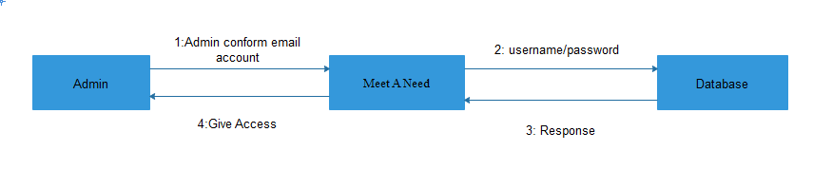

Figure 4.6.3

**Logout**

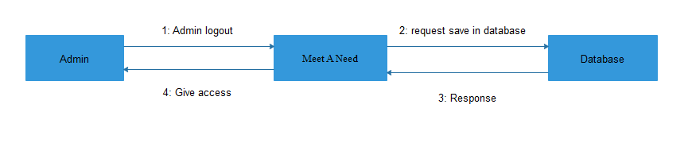

Figure 4.6.4

**Add a Hotel**

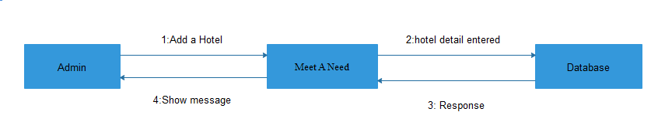

Figure 4.6.5

**View Hotel details**

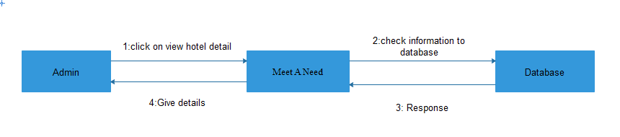

Figure 4.6.6

**Update Hotel details**

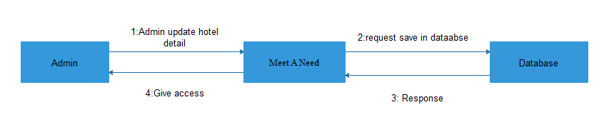

Figure 4.6.7

**Delete Hotel details**

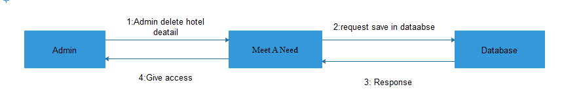

Figure 4.6.8

**Search Hotel details**

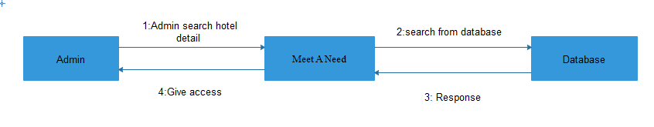

Figure 4.6.9

**Add a Restaurant**

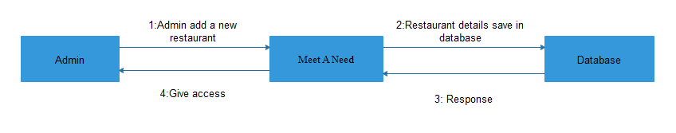

Figure 4.6.10

**View Restaurant details**

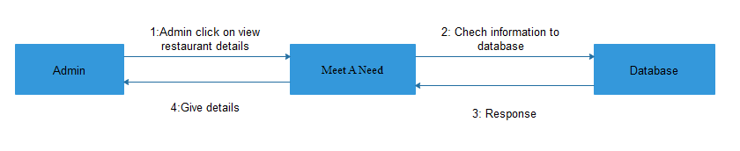

Figure 4.6.11

**Update Restaurant details**

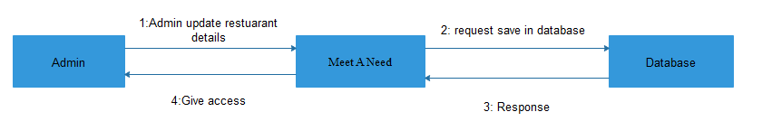

Figure 4.6.12

**Delete Restaurant details**

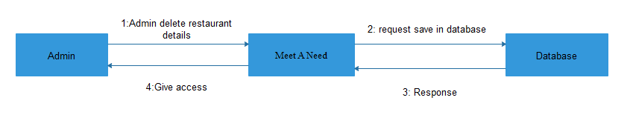

Figure 4.6.13

**Search Restaurant details**

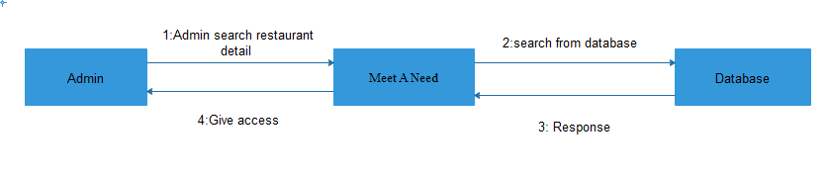

Figure 4.6.14

**Add a Hospital**

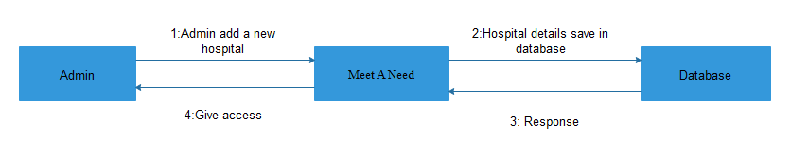

Figure 4.6.15

**View Hospital details**

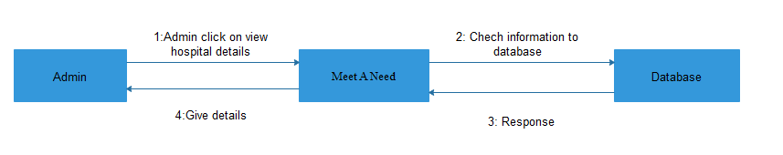

Figure 4.6.16

**Update Hospital details**

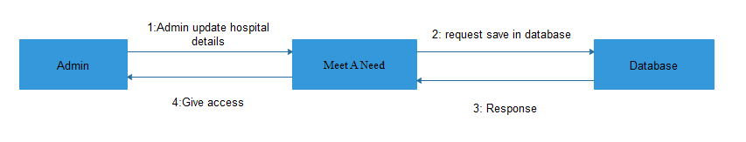

Figure 4.6.17

**Delete Hospital details**

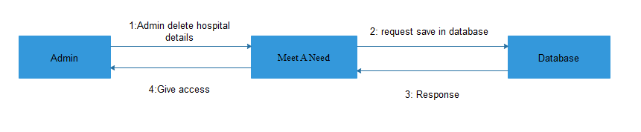

Figure 4.6.18

**Search Hospital details**

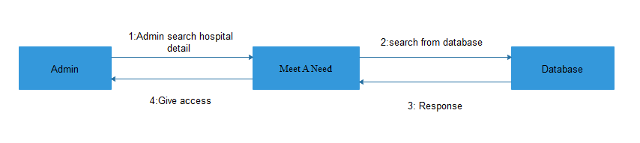

Figure 4.6.19

**Add a University**

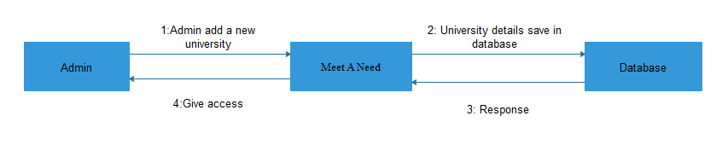

Figure 4.6.20

**View University details**

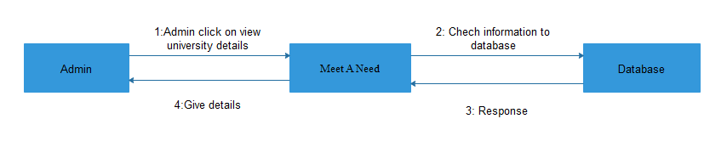

Figure 4.6.21

**Update University details**

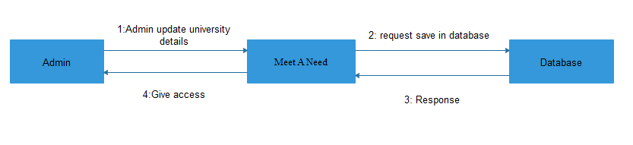

Figure 4.6.22

**Delete University details**

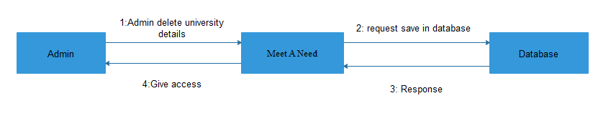

Figure 4.6.23

**Search University details**

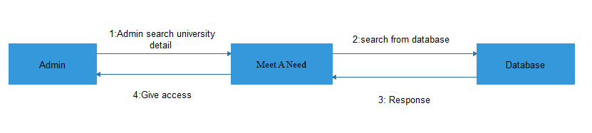

Figure 4.6.24

**MAN User**

* Signup
* Login
* Logout
* Recover password
* Search Hotel
* View Hotel details
* Search Restaurant
* View Restaurant details
* Search Hospital
* View Hospital details
* Search University
* View University details

**Signup**

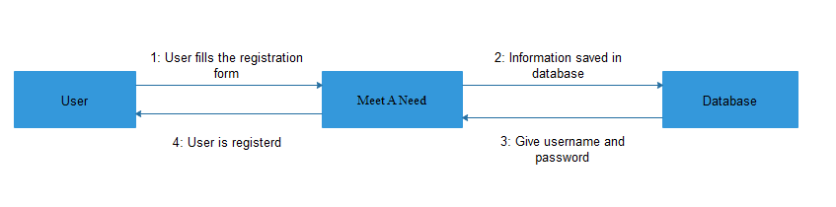

Figure 4.6.25

**Login**

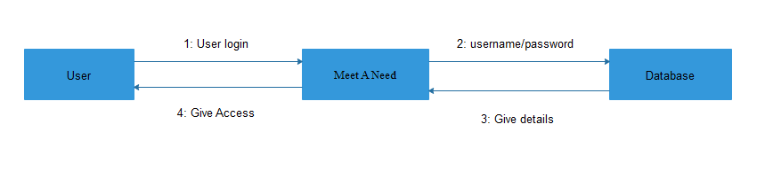

Figure 4.6.26

**Logout**

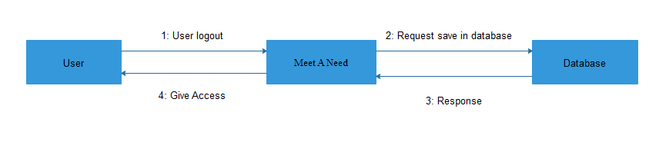

Figure 4.6.27

**Recover password**

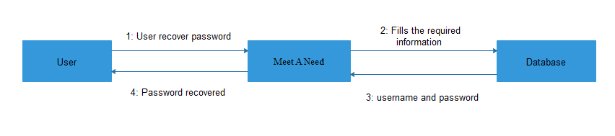

Figure 4.6.28

**Search Hotel**

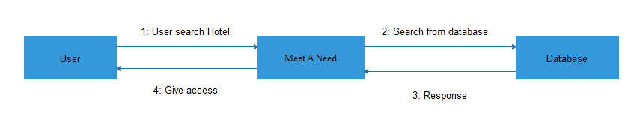

Figure 4.6.29

**View Hotel details**

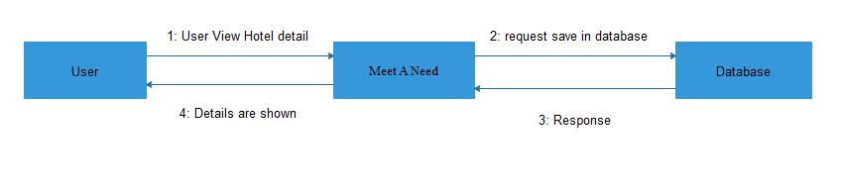

Figure 4.6.30

**Search Restaurant**

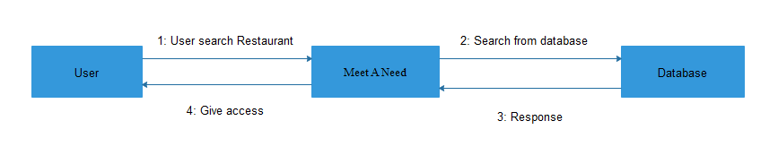

Figure 4.6.31

**View Restaurant details**

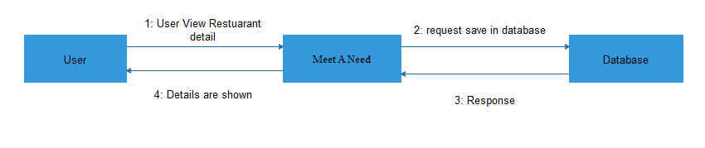

Figure 4.6.32

**Search Hospital**

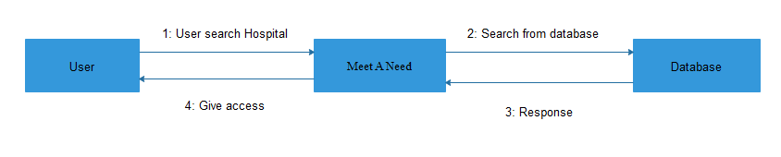

Figure 4.6.33

**View Hospital details**

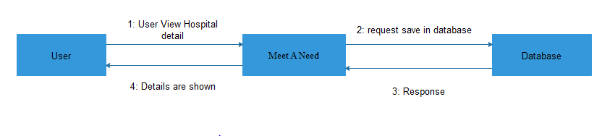

Figure 4.6.34

**Search University**

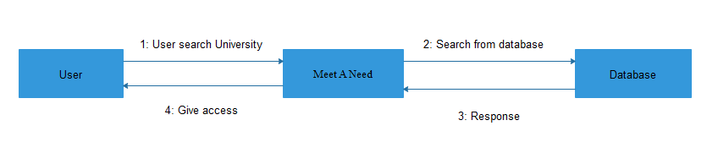

Figure 4.6.35

**View University details**

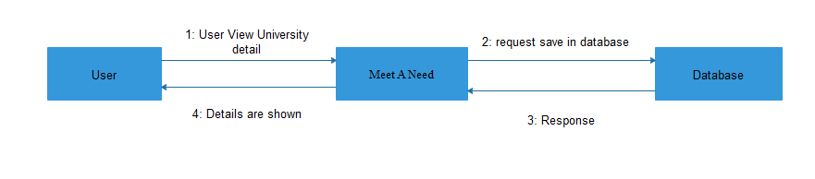

Figure 4.6.36

**State Transition Diagram**

A state diagram is a type of diagram used in computer science and related fields to describe the behavior of systems. State diagrams require that the system described is composed of a finite number of states sometimes, this is indeed the case, while at other times this is a reasonable abstraction. Many forms of state diagrams exist, which differ slightly and have different semantics.

**State Diagram**

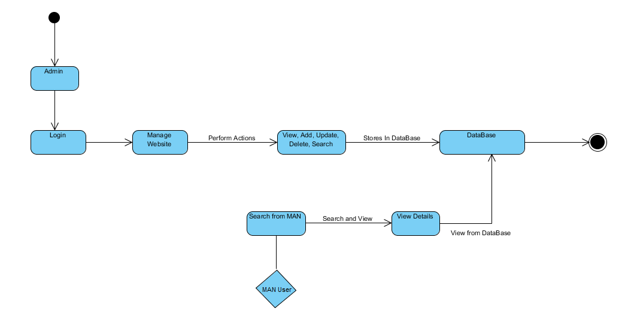

Figure 4-7

**Deployment Diagram**

Deployment diagram is a structure diagram which show architecture of the system as a deployment distribution of software artifacts to deployment target. Deployment is usually represented by a node which is either hardware device or some software execution environment. Nodes could be connected through communication paths to create networked systems of arbitrary complexity.

deployment diagram

Figure 4-8